Waukesha County Technical College
107-109 Visual Basic.Net/Database
Lab 7
Appointment Book Application

In this lab you will use the classes you have already created to in an Appointment Book Windows Application. You will also need to create a couple more classes for tracking contact information.

You will find attached to this document a set of form specifications for the Appointment Book Application. There are a number of forms described. The first form shown is the main form. The main form will drive activity in the application.

Below are listed a number of specifications for the application:

- When a date from the calendar control is selected on the main form, the appointments for that day will be displayed in a list box.

- The date selected from the calendar becomes the current date for activity.
When the application first starts the current date is today’s date.

- Entering information into the form and pressing the Add an Appointment button will add an appointment to the current date’s appointments.

- Selecting an appointment from the list box will allow a change/remove dialog form to appear so that changes can be made to the appointment.

- Selecting an appointment from the list box and then changing the contact, location or duration on the form followed by pressing the Change button will change the appointment selected. The changes should be reflected in the listbox.

- As you make changes or add appointments or important dates those changes should be reflected in list box on the form.

- Save will serialize all objects on to disk. When the application starts it should deserialize all objects from disk and display todays important dates in the listbox. If the data file does not exist then create the file and continue.

- As the user enters data into a form find ways to indicate invalid input that does not involve using a message box.

Phases for this Lab:

Phase 1. Make this application work with ImportantDate objects only. (No appointments, and no contacts) The application should display the important dates, anniversaries, birthdays for each date selected from the calendar control. The application should allow for the important dates to be changed and or removed.

Phase 2. Make this application work with ImportantDates and Appointments. (No contacts). The application should allow for add, change and delete of appointments and the appointments should display in the listbox appropriately.

Phase 3. Finish the remainder of the application.

Your instructor will demonstrate how to create a multiform application and how to link forms together using references.

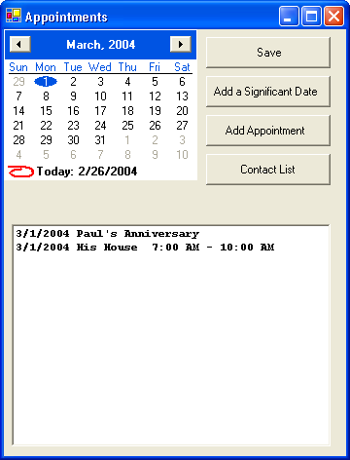

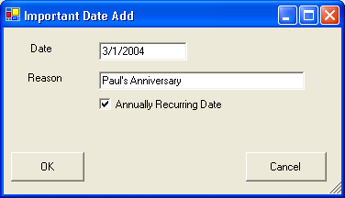

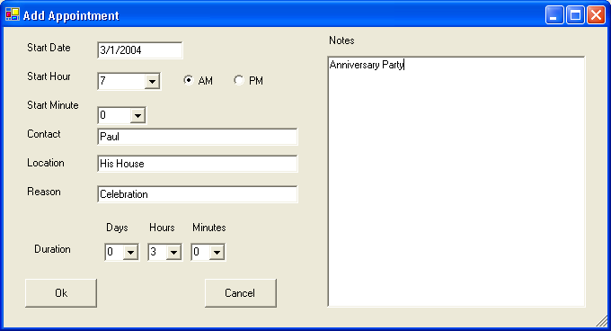
Selecting item from listbox triggers change/ remove
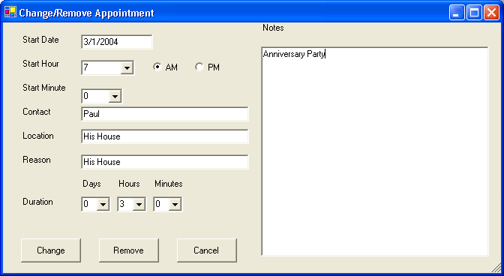

Selecting Important date item from listbox triggers Important Date Change / Remove dialog
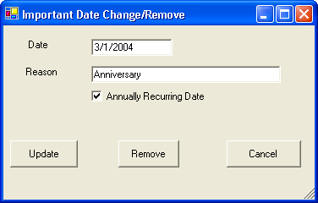

Form Layout for the list of contacts.
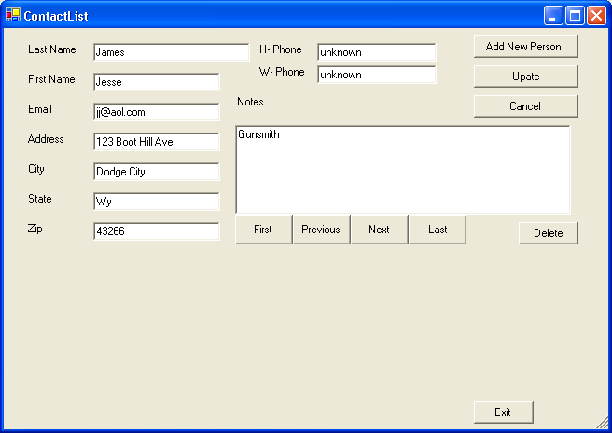

You will need to create a Contact and a ContactCollection class. Use this form to manage a list of contacts.

Extra Credit: 20 Pts. Add a data grid to the form that will allow you to manage (add, change and delete) important dates associated with this contact. These important dates should also be reflected in the main form.

